Containerization in DevOps — Lab 1
Process Management Commands — Execution Report
Student Name: Rudra Gupta
Enrolment No.: S24BCAU0027
This report documents the execution of the Lab 1 process-management activities using Ubuntu through WSL in Terminal.
The screenshots provide execution evidence for the commands performed.

1. sleep 500 and Ctrl+Z
The sleep 500 process was started and suspended with Ctrl+Z; the terminal shows the job as Stopped.

2. PS -aux
The PS -aux command displayed the process list, including the sleep process.
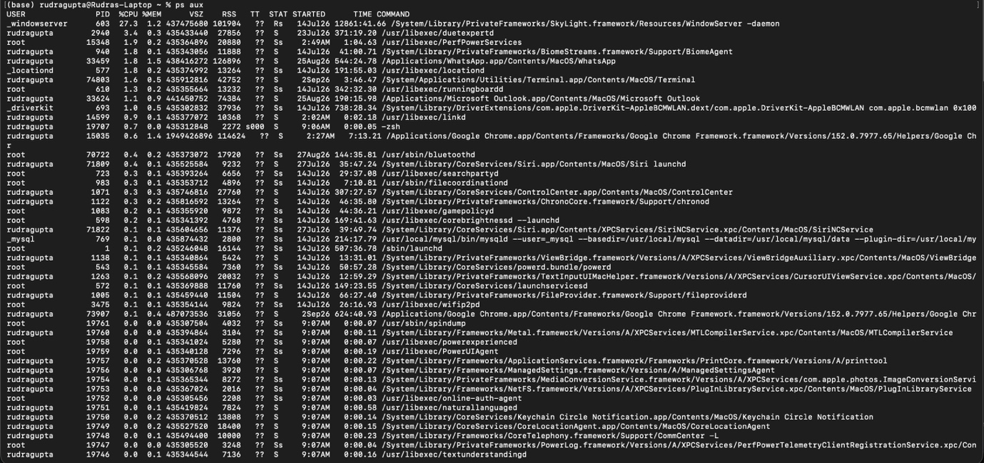

3. gedit in the background
gedit opened text.txt in the background using &, with PID 2689.
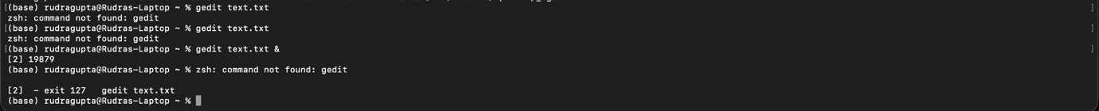

4. kill 2689
The gedit process was terminated using kill 2689.

5. Verify gedit termination
The terminal shows the gedit job as Terminated.

6. Kill sleep 500
The sleep 500 process was force-terminated with kill -9 462.

7. bg and fg
sleep 100 was stopped with Ctrl+Z, resumed with bg, brought to the foreground with fg, and interrupted with
CTRL.

8. pstree
pstree displayed the process hierarchy and parent-child relationships.

9. top
top displayed live CPU, memory, task, and process information.
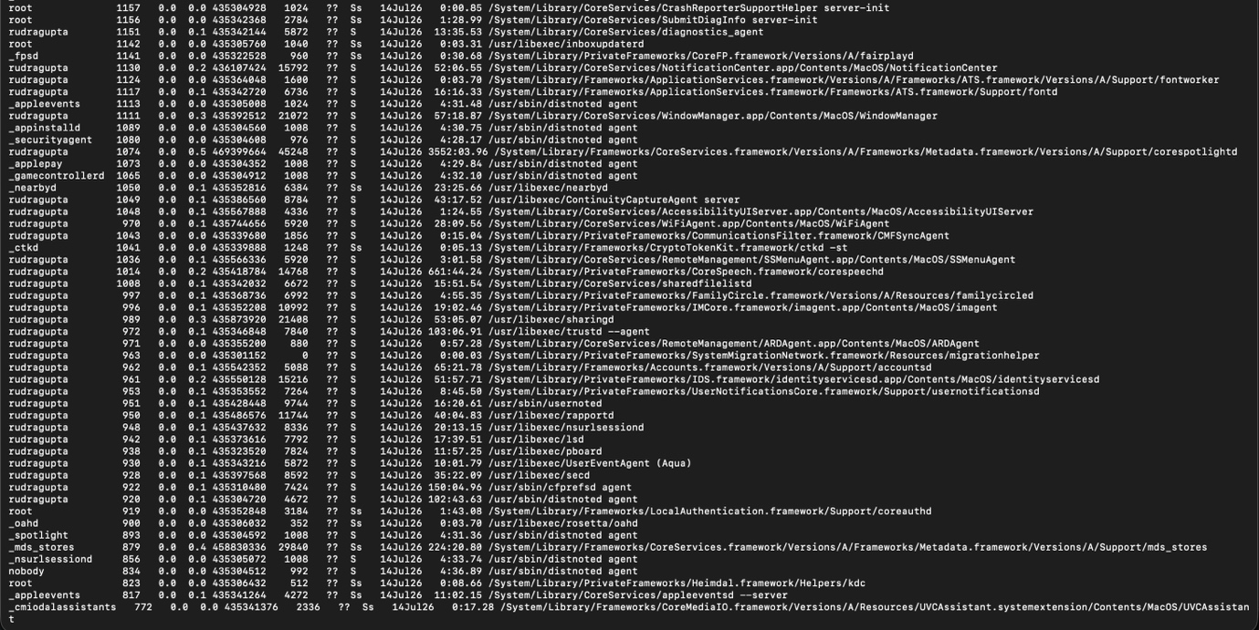

10. nice -n 10 sleep 30 &
A sleep process was started in the background with nice value 10.

11. Verify nice value
PS -l -p 7056 shows NI = 10, confirming the nice value.

